LAB ACTIVITY 4(i):

Writing Functions In Python

**Learning Outcomes:**

By the end of this laboratory session, you should be able to:

1. Display the use of parameters in functions
2. Construct Python function for returning result using return statement

**Hardware/Software:** Computer, Phyton 3.5 or above.

**Activity 4A**

Activity Outcome**:** Creating and calling a simple function

Procedure:

**Step 1:** Open Code editor and type the code based on the following code :

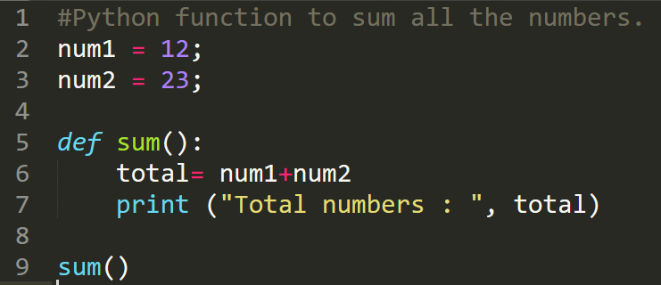

**Step 2:** Save, compile and run the program. Save the program as Act4A.py. Display the output in the area below.

**Output:**



**Activity 4B**

Activity Outcome: Creating and calling a simple function with a return value.

Procedure:

**Step 1:** Open code editor and type the following code:

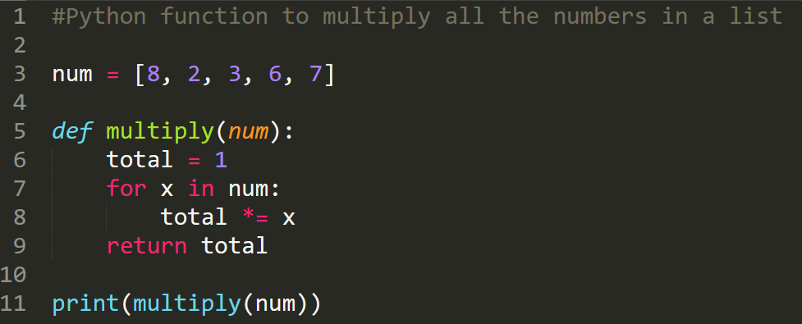

**Step 2:** Save, compile and run the program. Save the program as Act4B.py. Display the output in the area below.

**Output:**



**Activity 4C**

Activity Outcome : Construct a simple function with a return value.

Procedures:

**Step 1:** Open code editor and type the following code:

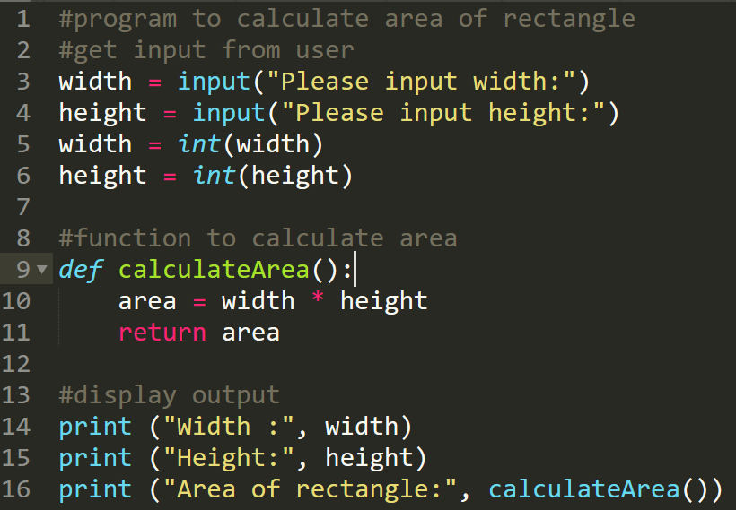

**Step 2:**  Save, compile, and run the program. Save the program as Act4C.py. Display the output in the area below.

**Output:**

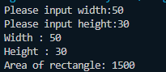

**Activity 4D**

Activity Outcome : Display the use of parameters in functions

Procedures:

**Step 1:** Open code editor and type the following code:

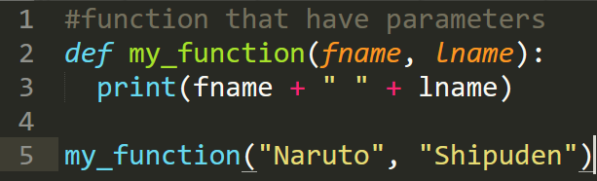

**Step 2:**  Save, compile and run the program. Save the program as Act4D.py. Display the output in the area below..

**Output:**



**Activity 4E**

Activity Outcome : Display the use of parameters in functions

Procedures:

**Step 1:** Open code editor and type the following code:

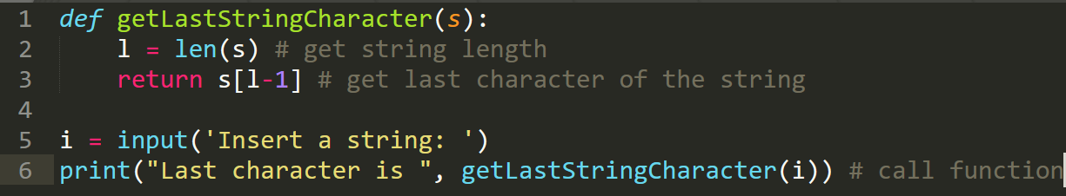

**Step 2:**  Save, compile and run the program. Save the program as Act4E.py. Display the output in the area below..

**Output:**

